Project Development Phase
Performance Test

Date | 03 october2026
Team ID | SWTID-2026-8181
Project Name | Script-Controlled ACL – Restrict Record Access Based on Field Value
Maximum Marks

Model Performance Testing:
Project team shall fill the following information in model performance testing template.
S.No. | Parameter | Screenshot / Values
1. | Data Rendered | Custom table: u_institution_details  Fields: Student Roll Number, Student Name, Faculty Name, Branch, Email, Phone Number, Description.  Branch values used: ECE, EEE, CSE. Read access is restricted so bb1 users see EEE records; Admin sees all records.  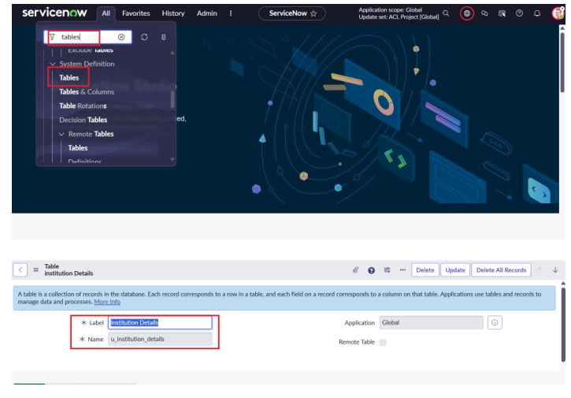  ServiceNow table and field setup  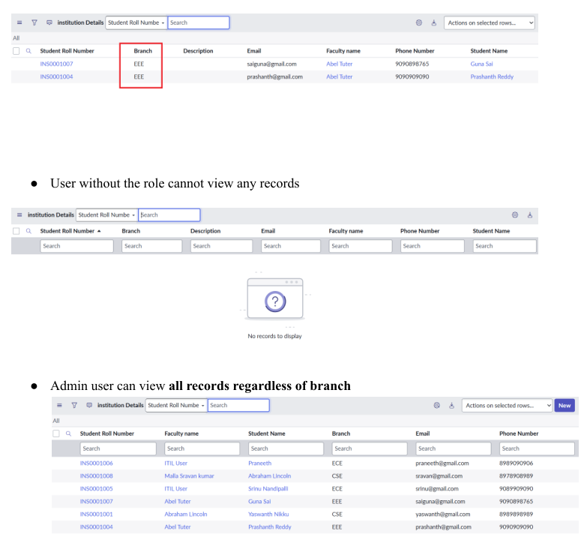  Read-access verification: EEE user vs Admin
2. | Data Preprocessing | No conventional data preprocessing is specified in the project. Access processing is performed at record level through the ACL.  Read ACL uses Data Condition: Branch is EEE, with script-controlled role checks. Create/Write/Delete ACLs use role requirements bb2, bb3 and bb4 respectively.  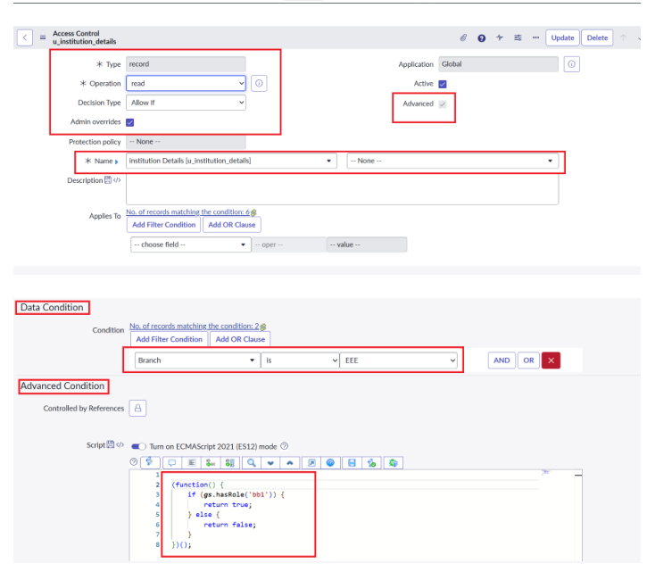  Read ACL: Branch = EEE + advanced script
3. | Utilization of Filters | ACL conditions/controls used:  • Data condition: Branch is EEE  • Read ACL role: bb1  • Create ACL role: bb2  • Write ACL role: bb3  • Delete ACL role: bb4  • Admin users retain full access in the read script.  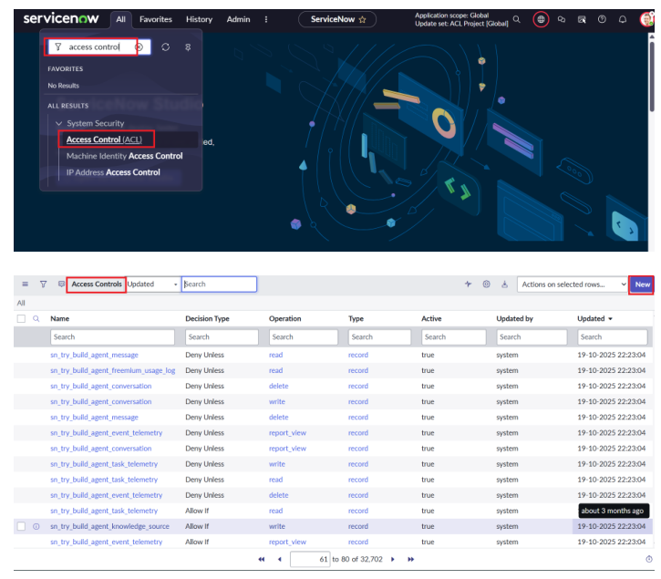  Create ACL configuration with bb2
4. | Calculation fields Used | None. The project does not specify calculated fields or formula-based calculations.  Security decisions are based on roles and the Branch field value rather than calculated fields.
5. | Dashboard design | Not applicable to this project. The source describes a ServiceNow ACL/security implementation rather than a Tableau dashboard.  No visualizations/graphs are specified in the project.
6. | Story Design | Not applicable to this project. No Tableau Story or story-point visualizations are specified in the source.

